## Section 36: The Philosophes– And Others

*The Enlightenment: A period of time preceding in the French Revolution that emphasized reason, science, natural law, education, reform, and tolerance.*

* The Spirit of Progress and Improvement
  + Define: Faith in Progress
  + Religious Fervor
    - Pietism:
  + John Wesley & Methodism:
* What were the Freemasons?
* The PHILOSOPHES: *French word for philosopher/* ALSO KNOWN AS_____________________

Who censored many things?

Church

Parlement of Paris

Royal officials

Printers’ Guilds

* + Not really original thinkers as a whole, but were great publicists of the new thinking ->
  + *How did censorship affect the style of writing during the Enlightenment?*
  + Salons : Helped to gather these philosophes and lead discussions.
    - Who is Madame de Geoffrin?
    - *What was the impact of salons or their hostesses have on philosophes?*

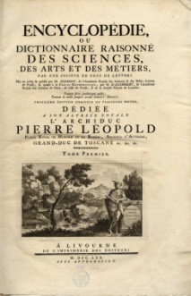

* Explain the importance of Diderot’s encyclopedia:
* French Enlightenment Thinkers’ Contributions

Similarities

Similarities

Similarities

* Political Economists:
  + **Physiocrats:**
* *What is free market and free trade?*
* *What is the relationship between supply and demand?*
* *What is the motivation for production?*
  + Major Beliefs:
    - opposed guild regulations
    - opposed price controls
    - first to use the term laissez - faire
* Economics arose from the activities of the physiocrats…